City of Ukiah
Notice of Public Hearing and Intent to Adopt a
Mitigated Negative Declaration for the Lookout Peak Trails Project

NOTICE IS HEREBY GIVEN that a Draft Initial Study/Mitigated Negative Declaration (IS/MND) under the California Environmental Quality Act was prepared and circulated for public review for the Lookout Peak Trails Project. A public hearing will now be held to consider adoption of the ISMND. See below.

PROJECT DESCRIPTION: The Project proposes the development of a passive-use public access trail system located in the Western Hills area of the Ukiah Valley, Mendocino County, California. The trail system is intended for non-motorized recreational uses including hiking, mountain biking, and general access to nature. The project area is situated on mostly undeveloped land within the Western Hills Watershed Protection Area and is consistent with the City’s adopted Western Hills Watershed Protection Area Management Plan, which identifies non-motorized recreational trails as an allowable land use.

PROJECT LOCATION: Recent lot line adjustments approved in January 2025 resulted in the current parcel boundaries for the project site (See Figures on reverse side). Public access to the trail system will be from two trailheads approximately 350 feet apart on Helen Avenue and Doolin Canyon Road.
PROJECT IMPACTS: The Draft ISMND prepared for the Project was circulated for public review from July 11, 2025 through August 11, 2025. As described throughout the Initial Study, temporary ground disturbing activities associated with vegetation removal and trail construction could result in direct significant impacts to Air Quality, Biological Resources, Hazards and Hazardous Materials, Hydrology and Water Quality, and Wildfire. However, mitigation measures identified within the aforementioned sections would reduce impacts to less than significant with mitigation incorporated. The IS/MND and associated documents can be found online at: http://www.cityofukiah.com/ceqa-review/ or at the Community Development Department, 300 Seminary Avenue, Ukiah, CA 95482.

HEARING DATE/TIME: On Wednesday, September 17, 2025 at 5:30 p.m. or soon thereafter, the Ukiah City Council will conduct a public hearing and consider adoption of the ISMND. The meeting will take place both in-person at the Civic Center Council Chambers, located at 300 Seminary Ave., Ukiah, CA, and via teleconference. Teleconference attendance details will be included on the agenda posted to the City website, https://cityofukiah.com/meetings/ and at the Civic Center Agenda Board no less than 72 hours prior to the meeting.

FOR MORE INFORMATION: All interested parties may contact Katherine Schaefers, Planning Manager 463-6203 or kschaefers@cityofukiah.com; or visit the Community Development Department, located at 300 Seminary Ave. Office hours: 8:00 am to 12:00 p.m. and 1:00 p.m. to 5:00 pm, Monday through Friday.

Project Location Figures

Figure 1. Parcel Boundary

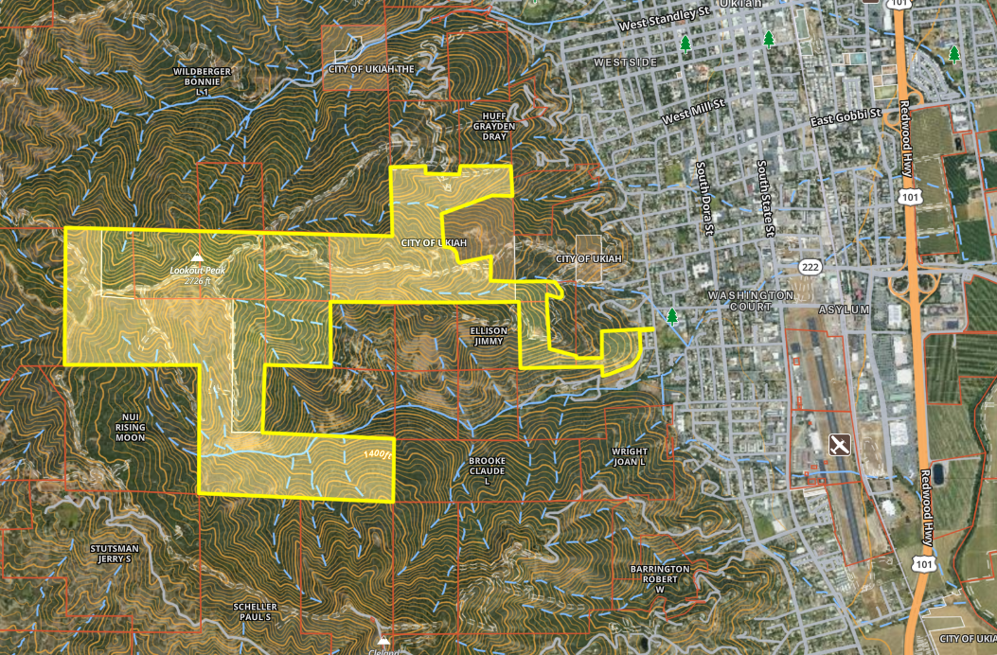

Figure 2. Trail Location within the Parcel

