Date: 02-19-2022
Location: 200 Block of E. Gobbi Street
Suspect: Mathew James Riley (21-year-old male of Ukiah)
Violations: 11351 HS - Possession for sale of narcotics Felony
11352(A) HS - Transportation / sale of narcotics Felony
11378 HS - Possession of a controlled substance for sale Felony
11379(A) HS - Transportation / sale of a controlled substance Felony
11370.1(A) HS - Possession of a controlled substance while armed with a loaded firearm Felony
11359(B) HS - Possess marijuana for sale Misdemeanor
24500(A)(1) PC - Carry a concealed firearm in a vehicle Felony
25800(A) PC - Carry a loaded firearm during a felony Felony
25850(A) PC - Carry a loaded firearm in public Felony
23900 PC - Alter / remove identification marks on a firearm Felony
32310(A) PC - Possession of high capacity magazines Felony
30605(A) PC - Illegally possess an assault rifle Felony

On 02/19/2022 at approximately 11:47 AM, UPD dispatch received a call reporting a male in a vehicle in the area of E. Gobbi St. and Waugh Ln. who appeared to be selling marijuana. The caller provided a description of the vehicle. A UPD officer arrived in the area and observed a vehicle that matched the description provided by the caller, exiting the parking lot onto Waugh Ln. The officer observed an equipment violation on the vehicle. The vehicle drove onto Waugh Ln., and then made an abrupt turn into an apartment complex’s parking lot. The officer conducted an enforcement stop on the vehicle and contacted the three occupants. The driver was identified as Mathew James Riley, and the other occupants were minors. The officer observed marijuana and marijuana paraphernalia inside the vehicle and within reach of the two minors.

Riley denied the behaviors reported by the caller, but admitted ownership of the marijuana and knowledge that the other occupants were minors. Riley and the other occupants were removed from the vehicle without incident and the officer’s investigation continued. A subsequent search of the vehicle and several backpacks within the vehicle resulted in the officer locating the following contraband:
- A semi-automatic 9mm handgun that was loaded, had a high capacity magazine and the serial numbers were obliterated.
- Three approximately 1-pound bags of marijuana
- Approximately 77.5 grams of Cocaine (approximately 774 dosage units)
- 65 Alprazolam prescription pills (controlled substance)
- 20 individual baggies containing MDMA “molly”
- Another baggie containing 1 gram of Cocaine
- 18 vials of CBD
- A concealed, loaded 9mm polymer 80 Glock style handgun (ghost gun), loaded with 30 rounds of ammunition.
- A concealed, loaded 9mm 80 Glock style handgun (ghost gun), loaded with 34 rounds of ammunition, with a threaded barrel.
  - The two polymer 80 handguns met the requirements to be classified as assault weapon
- Items of paraphernalia that were consistent with sales of controlled substances.

Riley was placed under arrest for the above-mentioned violations without incident. The two minors were released at the scene to their parents. Riley was booked at the MCSO Jail where he is being held on $50,00.00 bail.

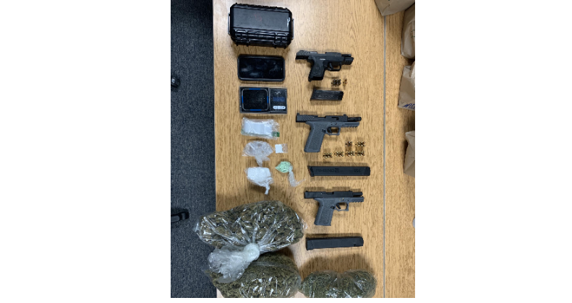

As always, our mission at UPD is to make Ukiah as safe a place as possible. If you would like to know more about crime in your neighborhood, you can sign up for telephone, cellphone, and email notifications by clicking the Nixle button on our website; www.ukiahpolice.com

