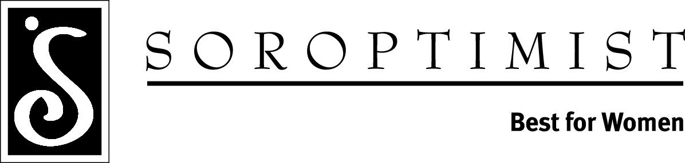

Soroptimist International of Ukiah

The Shirley Grover Law Enforcement/Public Safety Scholarship application is now available for graduating seniors and College Students at www.siukiah.org.

This scholarship is available to high school seniors and college students pursuing studies in Law Enforcement or Public Safety. Just visit our website at www.siukiah.org and download the application.
Scholarship Award - $1000.00
Deadline: April 20th

If you have questions or are unable to download the online application, please contact Janet Hunt at 707-459-0191 or email us at siukiah@soroptimist.net

